Twitter Bot

Python Programming Project

Hannah Ashna Jacob

N0865554 | Nottingham Trent University

**Aims:**

* 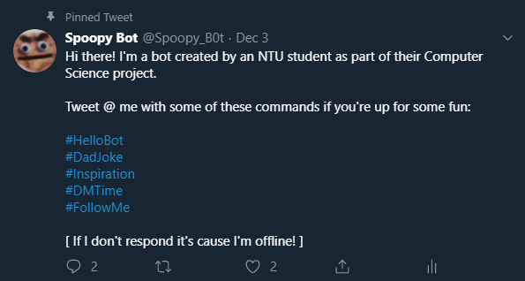To create a twitter bot that can have “tweet” conversations with other users whenever they mention it in a tweet.
* To create a bot that can have a simple/short direct message conversation with a user when the user initiates it using a #hashtag.
* To create a follower bot that follows people upon request via a hashtag (#FollowMe)

**Link:** <https://twitter.com/Spoopy_B0t/>

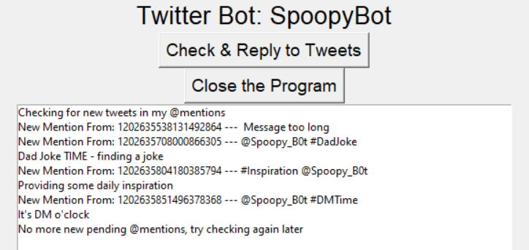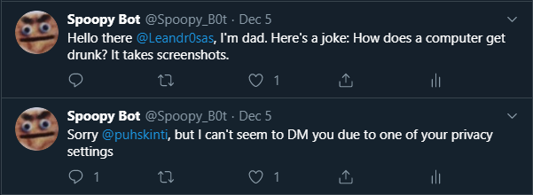

**Requirements:**

1. The program should be able to Authenticate the access tokens in order to obtain access to the twitter account and make tweets on its behalf. In addition to this, it should inform the user running the program that the authentication process is either successful or failure via the display box on the user interface (UI).
2. The program should be able to update the bot’s twitter biography (bio) to state that it’s online when it’s turned on and to state that it’s offline when it is turned off. This is done to ensure that the users tweeting at the bot are aware of its current status.
3. The program should be able to store the identification number (PreviousID) of the user it last responded to in order to prevent the bot from replying to them again when the program is run later. Subsequently, the program should be able to retrieve this identification number to use as the starting point in its search for new mentions.
4. The program should scan through the bot’s twitter mentions timeline and respond to each user with a response specific to the hashtag that they have used.

* #HelloBot: The bot should say hello back to the user and inform them of its list of commands
* #DadJoke: The bot should reply to the user with a randomly selected joke from the ‘Stored_Jokes’ text document.
* #DMTime: The bot should attempt to send the user a direct message.
* #Inspiration: The bot should reply to the user with a randomly selected quote from the ‘Stored_Quotes” text document.
* #FollowMe: The bot should attempt to follow the user on twitter

1. For each hashtag the bot should inform the user of what it is doing by updating the display box in the UI, if it fails to carry out the appropriate action it should inform the user via the display box.
2. The program should generate a user interface (using Tkinter) which display the title of the program, start and stop buttons as well as a display box that provides a user with status updates.

**Program Design:**

For the program to make any changes to the bot’s Twitter account it will first need access to Twitter’s Developer API tool wherein it will generate a set of secret tokens that allow for the program to make changes to the bot remotely (without having to log into twitter itself). Hence, if someone else wanted to use the bot for their twitter account they would simply have to sign up for the Developer API, get the corresponding tokens for their account and replace the tokens in the program.

**Main Program’s Flow chart:**

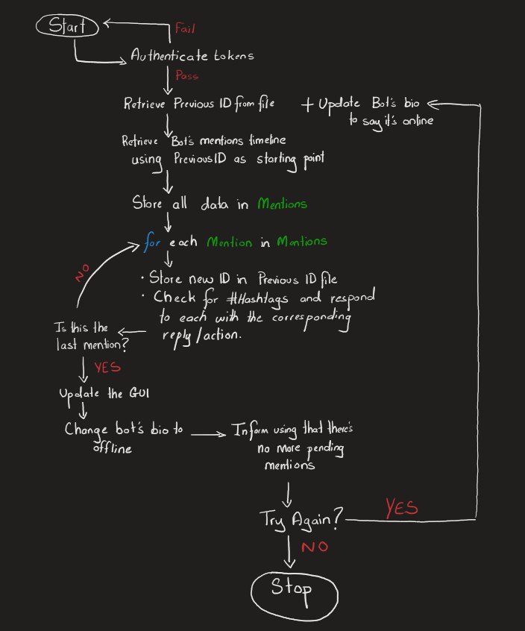

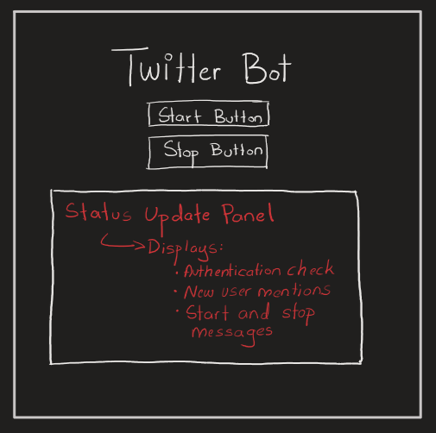**Design: User Interface**

The User Interface (UI) should have 2 main buttons:

* The start button: Runs the bot and has it search its timeline for new twitter mentions to respond to
* The stop button: Shuts down the bot and updates its bio to inform users it’s offline.

In addition to this, the UI should also have a display box that showcases all status updates that the main function will generate when it is run. This is done to keep users informed on what the box is currently doing.

**Design: Module**

Initially, the module was designed to separate the retrieval and allocation functions for the ‘PreviousID’ value from the Main file.

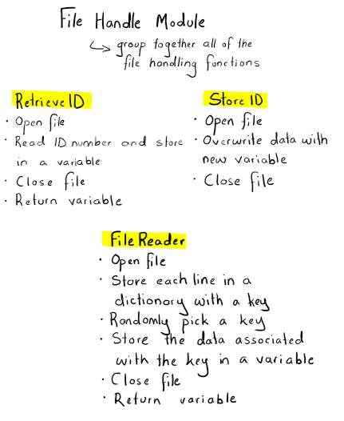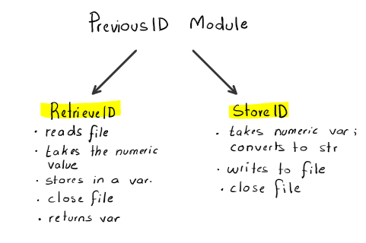However, upon further expansion of the program the module evolved into a File Handling module to help declutter the main script and ensure that all the file handling functions were grouped together to make the process of calling them in the main script easier.

**Testing:**

|  |  |  |  |
| --- | --- | --- | --- |
| **Feature** | **Test** | **Desired Outcome** | **Actual Outcome** |
| The authentication of tokens to obtain access to the twitter bot. | Run the program and press the ‘Check & Reply to tweets’ button  Alt: Manipulate one of the tokens prior to running the program by a single value to check whether an error message pops up | The program outputs “Authentication OK – Ready to go” in the display box  Alt: The program outputs “Error during authentication - Bot is unavailable” in the display box | Alt:    In addition to this, an error message generates in the console when the program has closed stating that it could not make changes to the bot due to it failing to authenticate the tokens. |
| The bot does not respond to the last person it replied to when the program is run again. | Make note of the last user the bot responded to before running the program and pressing the ‘Check & Reply to tweets’ button.  Once the bot has replied to all new mentions, go back to the bot’s timeline and go through its tweets and replies timeline to see whether it has skipped that user’s tweet and moved on to the more recent ones after it. | The bot responds to all new tweets after that user’s tweet. | The bot skips the previous user that it responded to and continues responding to the newer mentions after that one. |
| The bot stores the correct ID number of the last user it replied to. | Run the program and press the ‘Check & Reply to tweets’ button.  Once the program has run make note of the last user ID displayed in the UI. Stop the bot and check the Previous_ID.txt file. Compare the values. | Both values are the same. |  |
| The bot responds to the #HelloBot hashtag | Run the program and press the ‘Check & Reply to tweets’ button  Check the display box in the UI to see whether it was successful or not | The bot replies to the user with:  “Heyo! Thanks for checking in on me :) Hope you're having a swell day! Check out my pinned tweets for some cool commands.”  Display Box Outputs:  “Saying hello”  If twitter block’s the bot’s ability to respond or there’s an error the Display Box Outputs:  "Error: Unable to say hello" | If the process is successful, the display box outputs: “Saying hello”  If the process is un-successful, the display box outputs:  "Error: Unable to say hello" |
| The bot responds to the #DadJoke  hashtag | Run the program and press the ‘Check & Reply to tweets’ button  Check the display box in the UI to see whether it was successful or not | The bot replies to the user with a randomly selected joke from the Stored_Jokes.txt file    Display Box Outputs:  “Dad Joke TIME”  If twitter block’s the bot’s ability to respond or there’s an error the Display Box Outputs:  "Error: Unable to make a dad joke" | The bot picks a random joke from the file and responds to the user with it.  If the process is successful, the display box outputs: “Dad Joke TIME”  If the process is un-successful, the display box outputs:  "Error: Unable to make a dad joke" |
| The bot responds to the #DMTime  hashtag | Run the program and press the ‘Check & Reply to tweets’ button  Check the display box in the UI to see whether it was successful or not | The bot sends a user a direct message saying: “Send binary”    Display Box Outputs:  “It's DM o'clock”  If twitter block’s the bot’s ability to message them or there’s an error:  The bot replies to the user with:  "Sorry but I can't seem to DM you due to one of your privacy settings"  Display Box Outputs:  "Error: Unable to DM this person" | If the process is successful, the display box outputs: “It’s DM o’clock”  If the process is un-successful, the display box outputs:  “Error: Unable to DM this person” |
| The bot responds to the #Inspiration  hashtag | Run the program and press the ‘Check & Reply to tweets’ button  Check the display box in the UI to see whether it was successful or not | The bot replies to the user with a randomly selected quote from the Stored_Quotes.txt file    Display Box Outputs:  "Providing some daily inspiration"  If twitter block’s the bot’s ability to respond or there’s an error the Display Box Outputs:  "Error: Unable to send a quote" | The bot picks a random quote from the file and responds to the user with it  If the process is successful, the display box outputs: "Providing some daily inspiration"  If the process is un-successful, the display box outputs:  "Error: Unable to send a quote" |
| The bot responds to the #FollowMe  hashtag | Run the program and press the ‘Check & Reply to tweets’ button  Check the display box in the UI to see whether it was successful or not | The bot follows the user and if they already follow them it counts this as a success.  Display Box Outputs:  "Helping them up their follower count"  If twitter block’s the bot’s ability to respond or there’s an error the Display Box Outputs:  "Error: Unable to Follow this person" | When checking the bot’s follower list after the bot is run and a user uses the #FollowMe tag the bot now follows the user.  If the process is successful, the display box outputs: "Helping them up their follower count"  If the process is un-successful, the display box outputs:  "Error: Unable to Follow this person" |
| Bot updates it’s bio when it runs and when it stops | Run the program and press the ‘Check & Reply to tweets’ button. Visit the bot’s twitter profile and check whether it has updated the status.  Stop the program and visit the bot’s twitter profile and check whether it has updated the status. | Bot’s Bio updates to: "Hey there! I'm back online at the moment :) Feel free to message me!"  Bot’s Bio updates to: “Hey there! I'm currently offline at the moment but don't worry, I'll be back soon :D" | When the bot is turned on:  When the bot is turned off: |

**Critique:**

**Direct Message Conversation:**

One of the original aims of the program was to have the bot try and have a short conversation with a user whenever the #DMTime hashtag was used in a mention. However, due to Twitter’s privacy features, most users automatically have it so that if they don’t follow a user on twitter, this other user cannot direct message them. This became an issue when the bot would attempt to direct message (DM) someone and it would crash or do nothing because twitter would block this action.

Hence, instead of removing the feature entirely, I updated it using try/except so that the bot would still attempt to send one message and if that action failed, the bot would tweet at the person and inform them of this privacy feature.

**Private Accounts:**

Another issue that arose due to Twitter’s numerous privacy policies is that the bot cannot respond to anyone with a private twitter account. This is due to how the user’s tweets are protected and thus, the tweet mentioning the bot does not appear on the bot’s timeline. There is no workaround to this issue as this has been set in place by Twitter to protect user’s who wish to maintain some degree of privacy on the platform.

**Start and Stop Buttons:**

The start button for the bot doesn’t result in a continuous process of the bot checking for new mentions until it is told to stop. Instead, it asks the user to click it whenever they want it to check for new mentions. This is due to how when using loops with Tkinter buttons it causes the program to crash. When the start button was pressed it would remain pushed down due to the loop; this immediately resulted in the program freezing and crashing without given the user the opportunity to press the stop button.

Prior to creating a user interface (UI) for the bot program, it would ask for a Yes or No input via the IDE console to check whether the loop should keep running. Hence, a possible solution for this issue would be to replace the buttons with a typed-in user input option for the user interface.

**Hashtag Responsive:**

On the other hand, the bot program has been able to attain its other two aims. It can reply to all the hashtags with the appropriate response for each. Subsequently, it also follows a user upon request via the #FollowMe hashtag. Moreover, if a user tries to use several of the hashtag-commands in one tweet, the bot will consider all hashtags and provide a response for each one.

Due to the use of the .lower() function, a user does not have to worry about the proper capitalisation of the hashtag. The key element of using the hashtag commands is using the correct phrase.

A useful addition to the program would be to have a feature wherein if a user mentions the bot but with none of the hashtags, the bot can respond to that too; Currently, it only responds to users that use the specific hashtags.